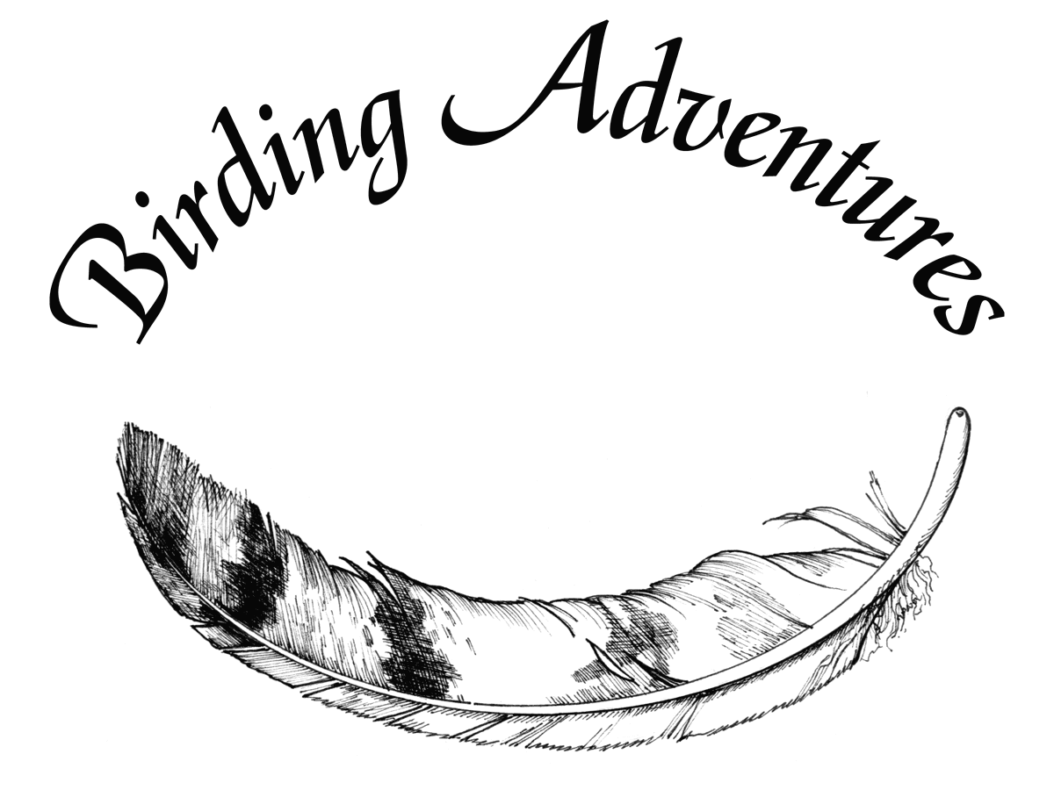
January, 2005
Owls of Minnesota
“You are going where? In January? Are you crazy?”
That was pretty much the general reaction I got from friends and family when I suggested a trip to the “Ya Betcha” land of Minnesota. I wanted to see owls—lots of them and this was the winter to do it.
The Duluth MN area was having a banner invasion year for Great Gray Owls and Northern Hawk Owls. Even the little Boreal Owls were caught up in the limelight. Hundreds of birders from all over the country flocked to Minnesota. Granted you could see these birds somewhere else in North America and in better weather in summer, but Sax Zim Bog, northwest of Duluth and Two Harbors, northeast of Duluth, had entertaining hundreds of Great Gray Owls since December.
“So who wants to go?” I replied. Surprisingly, not all my birding buddies wanted to leave the warmth of Georgia for the cold. Even my own husband had a ‘conflict’, so he said. (I’m not too sure if he was truly disappointed!)
But I was serious and, finally, four of us were willing and able to do a little “power birding” to see the owls. Leslie Curran, Theresa Hartz, Jane Shero and I were set.
Well, almost. Jane lives in Milwaukee, so Leslie, Theresa and I flew there and then drove up to Duluth with Jane. Only 400 miles, we thought, and we’ll get some good birds along the way as we drive north to Duluth and back south again. In fact, we did see some good birds.
We flew from Atlanta to Milwaukee on Wednesday, January 19. Jane drove from her home in Milwaukee to Eau Claire where we spent the night. The next morning we took off in beautiful new snowfall. Along the drive to Duluth, we spotted five Bald Eagles, six Rough-legged Hawks, 24 Red-tailed Hawks, and one Barn Owl. Our best bird was a Northern Hawk Owl delicately perched in a tree top along the interstate.We pulled over and got the scope on that bird, enjoying it for awhile. We also saw a nice flock of Wild Turkeys in a field, a large flock of Common Redpolls, and one Northern Shrike on a power line. You might wonder how we managed to pull over on the interstate, but the road was basically empty of traffic. No one in their right mind was out today.
We drove through Superior WI, through downtown Duluth MN and made our first stop at the Duluth International Airport. There had been reports of Snowy Owls there. Theresa did not have a wild Snowy Owl on her list. We had seen 12 rehabbed Snowy Owls released along the shore of the Hudson Bay in Churchill, Manitoba two summers ago, but those birds didn’t count. These Duluth airport birds were wild and countable.
Leslie spotted one Snowy on the top of an orange and white tower far out past the runway, but close enough with the scope to make it out as an immature male. This quickly became a three-owl trip—Barn, Northern Hawk and Snowy.
Off we dashed (as much as you can dash on snowy roads) to Two Harbors in search of the Boreal Owl. Reports had one behind the high school in the fir trees, but in spite of a cold 14 degree hour-long search, we could not come up with it. Somewhat disheartened, we checked Agate Bay for Harlequin Ducks (nope) and the Long-tailed Duck (nope), but did see many Common Goldeneyes and one Common Merganser in the ice cold water.
It was getting late in the afternoon, almost dusk, so we decided to call it quits and head back for Duluth. Our return was delayed when I received a call from Laura Erickson, a great birder from Duluth (she actually lives there…there are lots of birders living in cold Duluth even in the winter!). She had just gotten a call from someone in Two Harbors that a Boreal Owl was perched in an apple tree in a backyard.
I’m fairly well-known for making sudden U-turns and this was no exception. Of course, Jane was driving (it was her car) but with very little urging, she expertly swung it around and we quickly headed back for an incredibly long 10 minutes to Two Harbors racing against the darkness. We piled out at the corner house, crunched our way in snow down along the street to the designated backyard and immediately saw the Boreal sitting in the apple tree. That was a new bird for all of us and we graciously thanked the birder that called it in when he arrived a few minutes after us. We owe him a drink.
A three owl day! Laura commented later that she didn’t know of anyone coming up to Duluth and seeing Snowy, Northern Hawk and Boreal all before seeing the Great Grays.
Back in Duluth, happy and victorious, we toasted to a great day. And we made our plans for Friday at Sax Zim Bog. Laura agreed to come with us, which we truly appreciated since she knew where the best bird feeders were for Common Redpolls, Pine Grosbeaks, etc.
We got to Sax Zim Bog early enough the next morning (Friday, January 21) to cruise the roads, counting Great Gray Owls along the way. In total, we saw 18 of them. This was now a five-owl trip. Most of the birds were sitting on power lines, some on tree tops; most very close to the road. We never got out of the car so as not to scare them or disturb them from hunting. Since there were so many of them in this area, exceeding the carrying capacity, some were dying and some were dispersing farther southwest towards Minneapolis and St. Paul. We certainly did not want to cause them any more stress.
One bird dropped down to the snow, spread its wings out, and grabbed whatever prey it had heard or seen. It then flew back up to the power line. Incredible.
We also got great long looks at Black-backed Woodpecker, Northern Shrike, Ruffed Grouse, Pine and Evening Grosbeaks, Snow Buntings, and a Bald Eagle. My favorite winter songbirds for the trip were seen just before noon—Bohemian Waxwings—all next to the road eating berries.
It was a contented and happy four-some that returned to Duluth that night. We celebrated our five-owl trip at dinner.
Leaving Duluth the next morning (Saturday Jan 22), we decided to try for gulls at the Superior Wisconsin landfill. Only birders can appreciate landfills and sewage treatment ponds! The gate was closed, however, to the landfill, so we drove down the unplowed road past the fenced in area. No gulls. Hmmmmmm, it didn’t look too good going farther down that road either. Jane did another U-turn. But this time, the snow wasn’t as obliging as before. We got stuck. “No problem” we shouted, jumped out, shoveled away the snow and pushed the car back and forth. We were quite proud of ourselves, living on the edge here, about one mile from civilization!
The drive back to Milwaukee was uneventful except for more Rough-legged Hawks, five Bald Eagles and another Northern Shrike. We were triumphant—we got our birds, survived the cold temperatures in the teens, drove in a whole lot more snow than we are used to here in Georgia, and got out of a snow-jam.
SPECIES SEEN
Canada Goose
Bufflehead
Common Goldeneye
Common Merganser
Ruffed Grouse
Wild Turkey
Bald Eagle
Red-tailed Hawk
Rough-legged Hawk
Rock Pigeon
Great Gray Owl
Barn Owl
Boreal Owl
Northern Hawk Owl
Snowy Owl
Hairy Woodpecker
Downy Woodpecker
Black-backed Woodpecker
Pileated Woodpecker
Northern Shrike
American Crow
Common Raven
Gray Jay
Blue Jay
Black-capped Chickadee
White-breasted Nuthatch
Red-breasted Nuthatch
European Starling
Bohemian Waxwing
Pine Grosbeak
Common Redpoll
Evening Grosbeak
Snow Bunting
House Sparrow
Birding Adventures, Inc.
Georgann Schmalz
Ornithologist
www.birdingadventuresinc.com
georgannschmalz@windstream.net

